

TASK 16 - EXTENDED RESPONSE 3 (SCIENCE AS A HUMAN ENDEAVOUR)

AQUEOUS SOLUTIONS AND ACIDITY (10 marks)

The map below shows the catchment for a town water supply. Describe two possible sources of contamination in this area. Three processes are required to be carried out before the people in the town use the water. Give a reason why each process is necessary and describe a method. Explain how these methods may be influenced by economic and social factors.

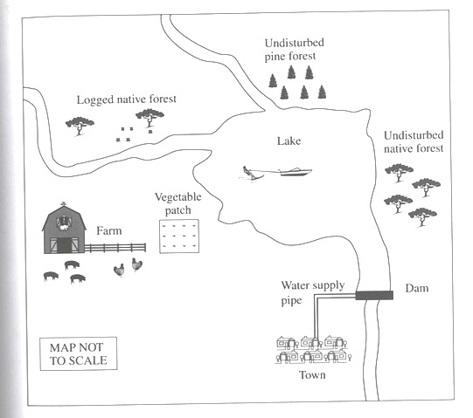

Salty Lake

Describe two possible sources of contamination: (2 marks)

1. __________________________________________________________________________________________________________________________________________
2. __________________________________________________________________________________________________________________________________________

Describe each method and give a reason why each process is necessary. (6 marks)

(clearly number each process)

|  |
| --- |
|  |
|  |
|  |
|  |
|  |
|  |
|  |
|  |
|  |
|  |
|  |
|  |
|  |
|  |
|  |
|  |
|  |
|  |
|  |
|  |
|  |
|  |
|  |
|  |
|  |
|  |
|  |
|  |
|  |
|  |

Economic Factors (1 mark)

_________________________________________________________________________________________________________________________________________________________________________________________________________________________________

Social factors (1 mark)

_________________________________________________________________________________________________________________________________________________________________________________________________________________________________